Supplementary Tables and Figures
Room temperature roll-to-roll additive manufacturing of polydimethylsiloxane-based centrifugal microfluidic device for on-site isolation of ribonucleic acid from whole blood

^{1,3}Trung Hoang, ^{1,3,5}Han Truong, ^{1,3,5}Jiyeon Han, ²Saebom Lee, ²Jihyeong Lee, ^{4,5}Sajjan Parajuli, ^{1,2}Jinkee Lee*, ^{1,3,4,5}GyouJin Cho*

¹Institute of Quantum Biophysics, Sungkyunkwan University, Suwon, Korea.

²School of Mechanical Engineering, Sungkyunkwan University, Suwon, Korea

³Department of Biophysics, Sungkyunkwan University, Suwon, Korea

⁴Research Engineering Center for R2R Printed Flexible Computer, Sungkyunkwan University, Suwon, Korea

⁵Department of Intelligent Precision Healthcare Convergence, Sungkyunkwan University, Suwon, Korea

*Corresponding author:
Name: Jinkee Lee, GyouJin Cho
Address: Institute of Quantum Biophysics, Department of Biophysics, Sungkyunkwan University, Suwon, Republic of Korea
E-mail: lee.jinkee@skku.edu; gcho1004@g.skku.edu

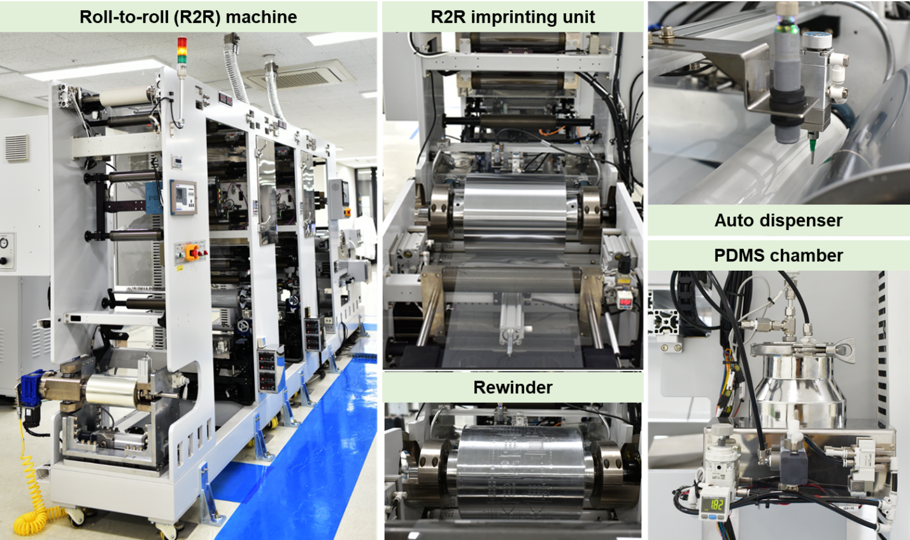
a
b

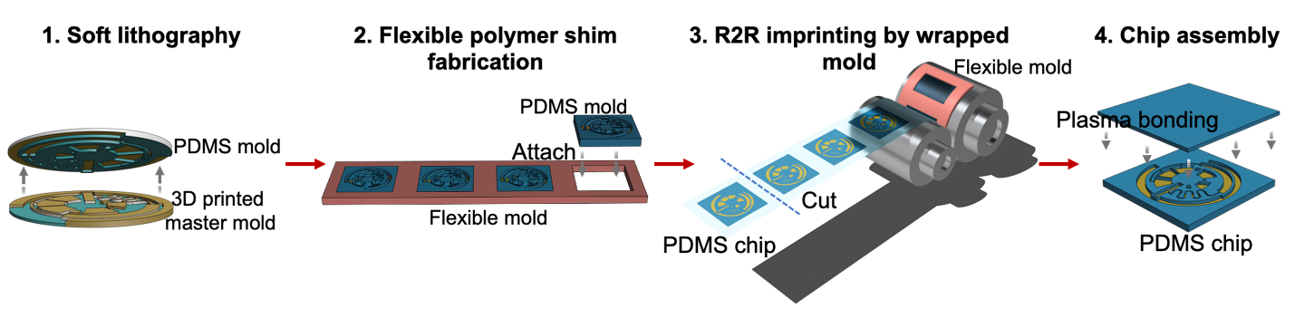
Fig S1. (a) A detailed structure of the roll-to-roll imprinting unit.
(b) Schematic images of step-by-step manufacturing process of PDMS based LoaD devices.

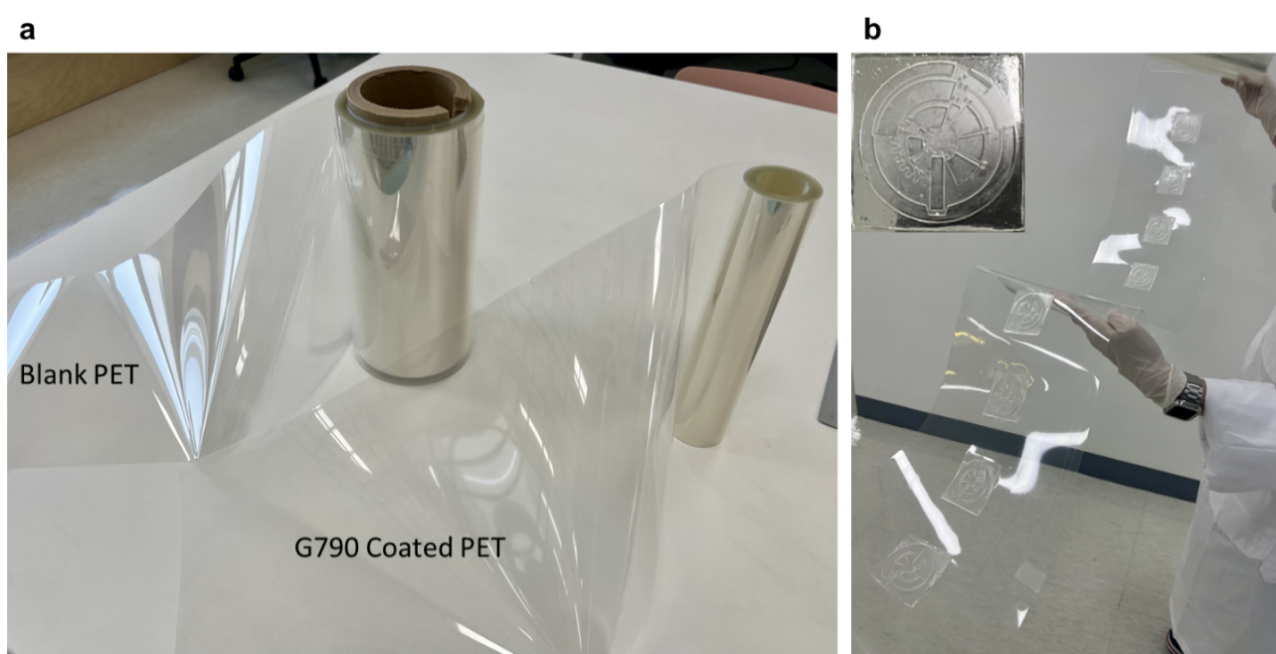Fig S2. Products manufactured by R2R systems. (a) PET substrates before & after treated with adhesion promoter by gravure coating methods; (b) Imprinted chip on PET substrates.

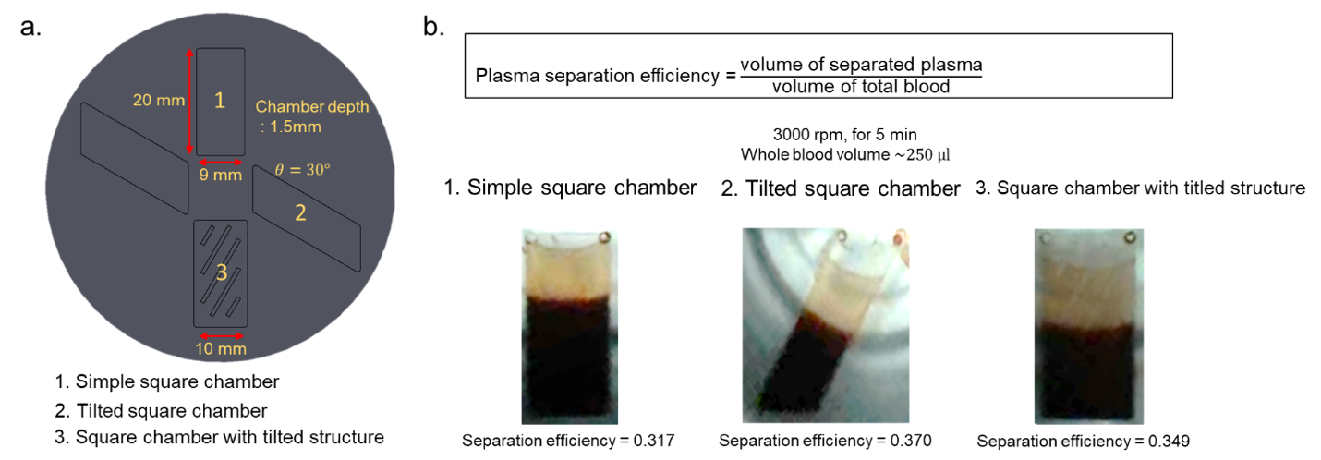Fig S3. Design of plasma separation chamber on centrifugal microfluidic devices. (a) 3D design of plasma separation chamber with different geometries; (b) Plasma separation efficiency measurement by experimenting on different chamber designs.

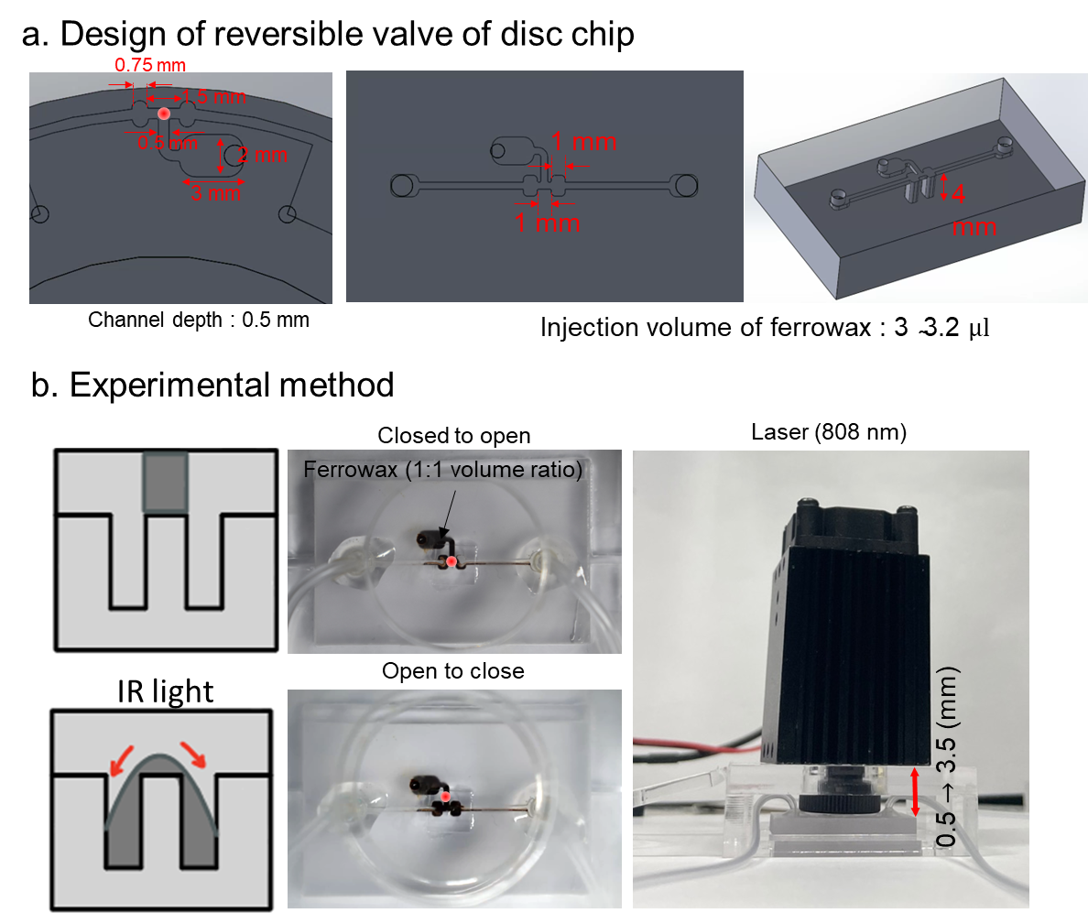Fig S4. Demonstration of the actuation mechanism of ferro-wax valves integrating on our chip devices.

Table S1. Autofluorescence intensity of glass and three PDMS formulations at four different excitation wavelengths.
 | DAPI | FITC | TRITC | CY5
Glass | 388.16 ± 0.1 | 398.64 ± 0.15 | 391 ± 0.11 | 398.17 ± 0.06
Sylgard 184 | 389.57 ± 0.01 | 401.94 ± 0.1 | 392.02 ± 0.04 | 396.97 ± 0.05
Vinyl-terminated PDMS | 390.56 ± 0.04 | 392.88 ± 0.18 | 390.44 ± 0.32 | 396.7 ± 0.06
Room-temp PDMS | 389.78 ± 0.16 | 399.91 ± 0.13 | 391.76 ± 0.12 | 393.13 ± 0.07

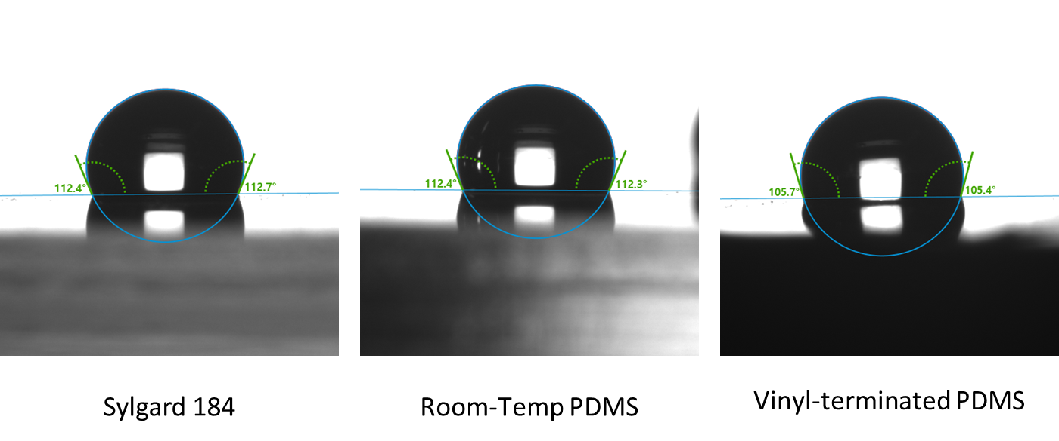Fig S5. Water contact angle measurements of PDMS samples.

Table S2. Optimization of R2R imprinting parameters
Applied nip Pressure  (kgf/cm²) | Web transfer speed  (mm/s) | Roll temperature  (ºC) | Humidity  (%) | Replication accuracy
 |  |  |  | Height | Width
1 | 0.3 | 25 | 45 | 99% | 99%
4 | 0.3 | 25 | 45 | 71.7% | 92.50%
10 | 0.3 | 25 | 45 | 69.5% | 92%

Table S3. Operation steps for RNA isolation on R2R imprinted lab-on-a-disc
 | Step | Rotational speed (rpm) | Time(s) | Operation
1 | Plasma separation | 2000 | 180
2 | Lyse | - | 10 | Valve 1 open
3 | Lyse | 1000 | 30 | Channel mixing (Plasma, Binding buffer, Proteinase K)
4 | Lyse | - | 10 | Valve 2 close
5 | Binding | - | 10 | Valve 3 open (Ethanol)
6 | Binding | 1000 | 15 | Transfer ethanol to mixing chamber
7 | Binding | Mix | 30 | Chamber mixing
8 | Binding | - | 600 | Incubate at 60⁰C
9 | Binding | - | 10 | Valve 4 open
10 | Binding | 1000 | 15 | Transfer magnetic nanobeads to mixing chamber
11 | Binding | Mix | 60 | Mixing lysate mixture with magnetic nanobeads and incubate at room temperature (RT)
12 | Binding | - | 10 | Valve 5 open (waste chamber)
13 | Binding | 1000 | 15 | Transfer the aqueous mixture to waste chamber
14 | Wash | - | 20 | Valve 5 close (waste chamber), Valve 6 open (VWM1)
15 | Wash | 1000 | 15 | Transfer VWM1 buffer to mixing chamber
16 | Wash | Mix | 30 | Chamber mixing
17 | Wash | - | 10 | Valve 5 open (waste chamber)
18 | Wash | 1000 | 15 | Transfer VWM1 buffer to waste chamber
19 | Wash | - | 180 | Repeat 13-17 process with RWA2, WE buffer.
20 | Elute | - | 10 | Valve 5 close (waste chamber), Valve 9 open
21 | Elute | 1000 | 15 | Transfer ER buffer to mixing chamber
22 | Elute | Mix | 30 | Chamber mixing
23 | Elute | - | 10 | Valve 10 open (Elution chamber)
24 | Elute | 1000 | 15 | Transfer solution to elution chamber

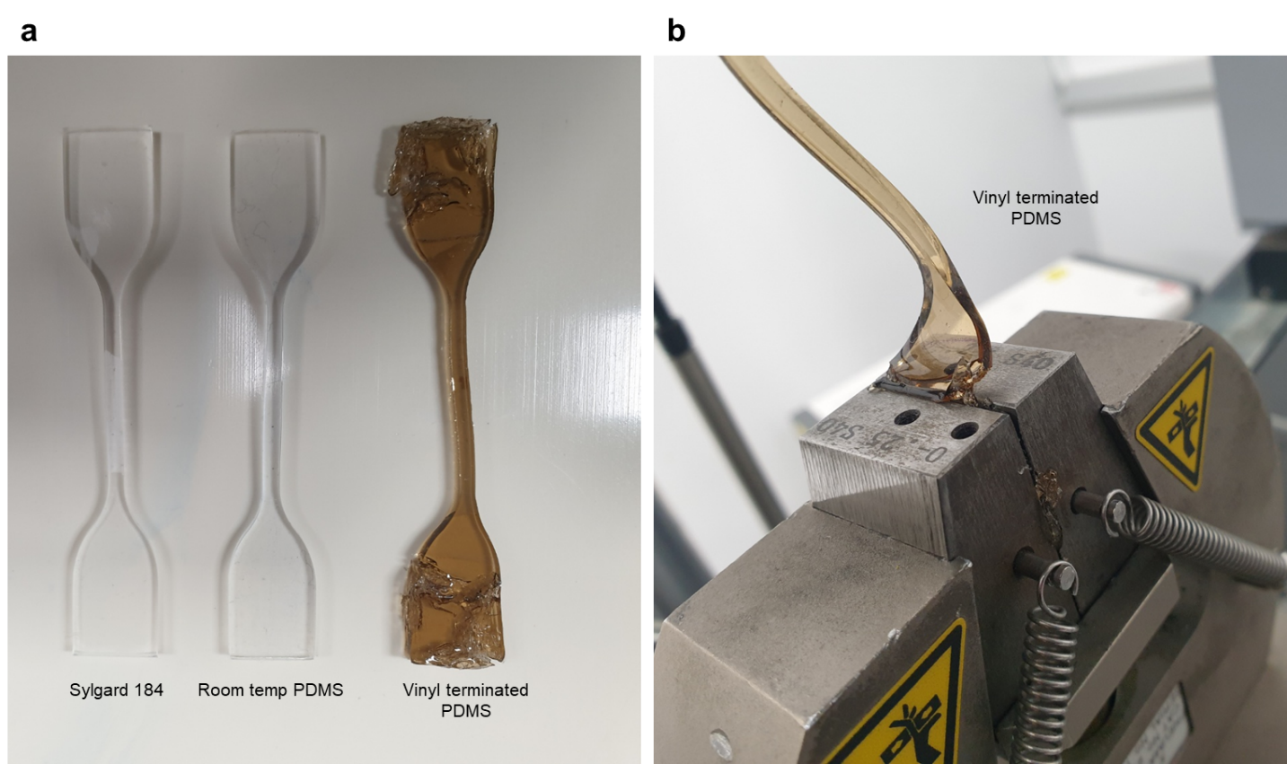Fig S6. Failure of tensile measurement on vinyl terminated PDMS samples due to low modulus. (a) Comparison of three types of PDMS after gripping on tensile measurement machine; (b) Crack formation of vinyl-terminated PDMS during gripping process.

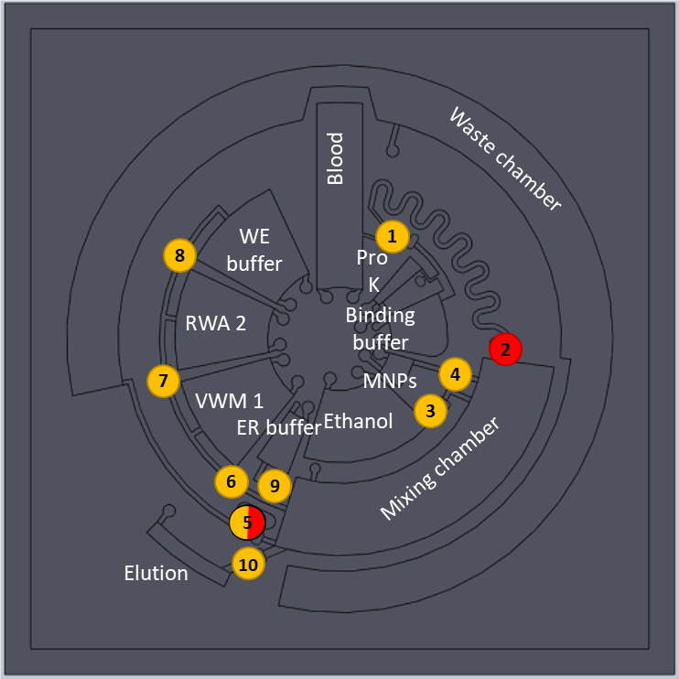
Fig. S7. Snapshot images of the top surface design of centrifugal microfluidic devices.

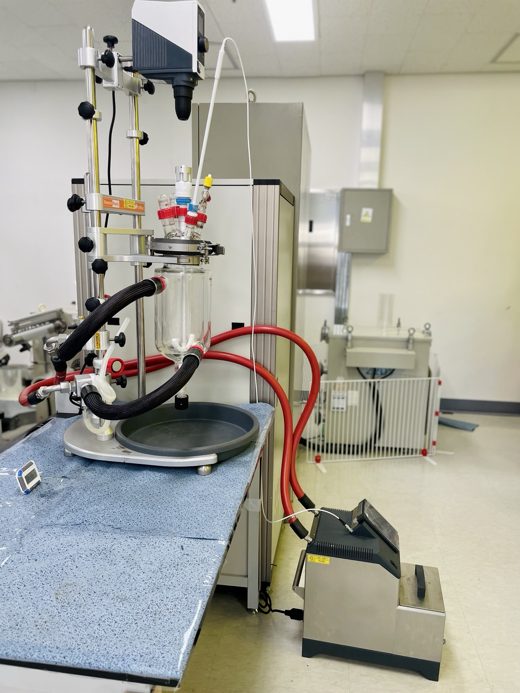
Fig. S8. Reactor systems for storing PDMS mixture during the R2R imprinting operation

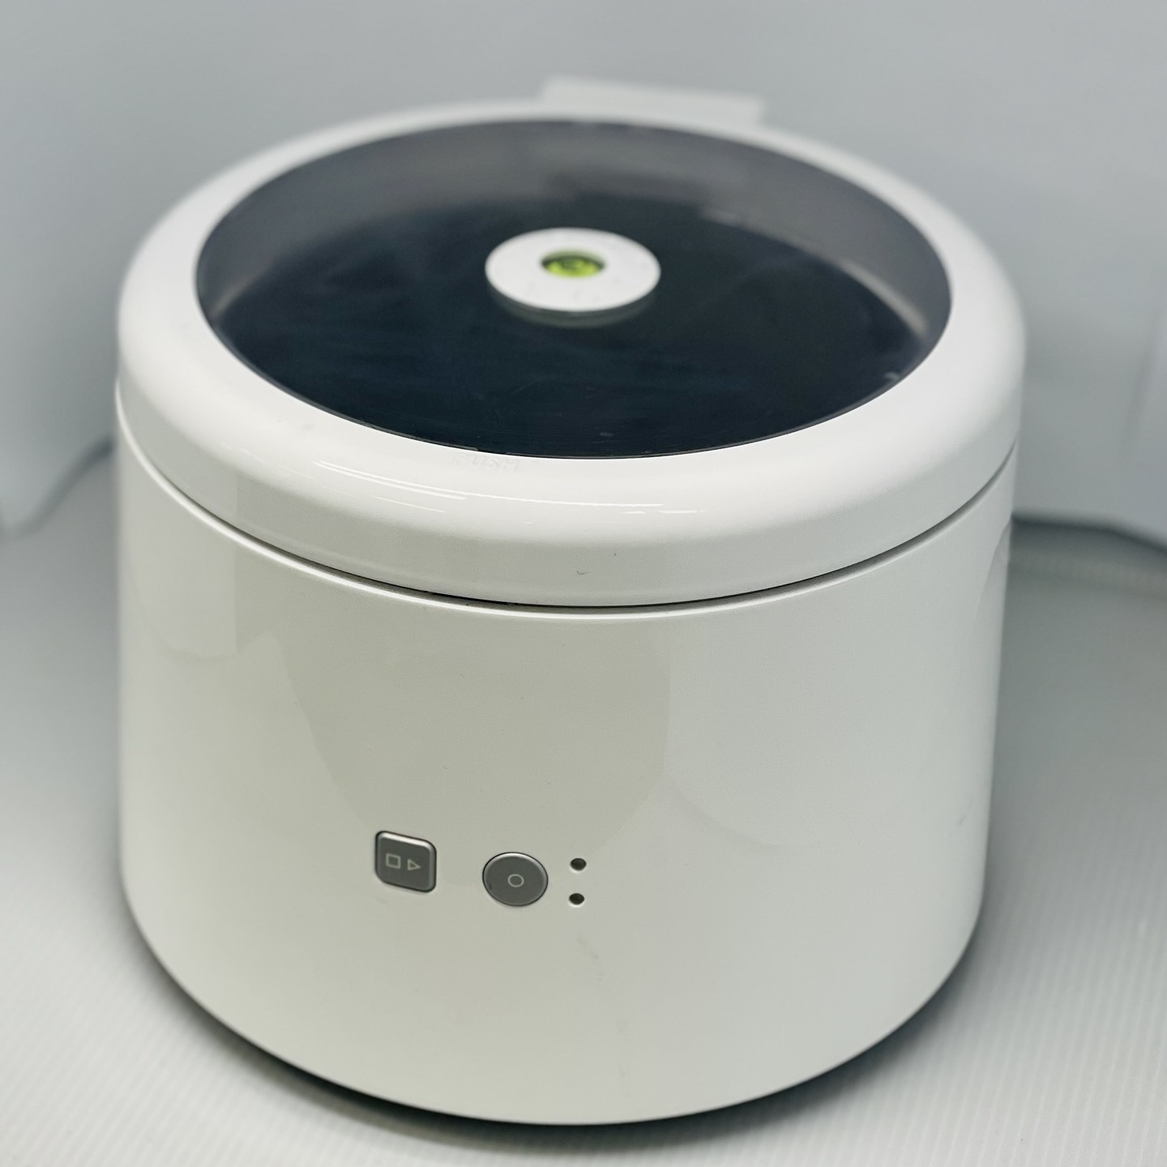
Fig. S9. The centrifugal machine made by Optolane (Korea) company.

Fig. S10. Design and optimization of current flexible mold space for enhancing production rate.

